Installing Sencha Cmd
The build process requires Sencha Cmd of the Studio Client workspace. You can download an installer from the following download URL:
https://www.sencha.com/products/extjs/cmd-download/
Please make sure that you installed version 7.2.x.
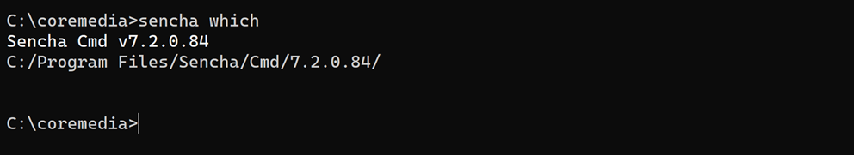
Memory settings for Sencha Cmd
You should also check the memory settings of Sencha Cmd. These settings are defined in the file "sencha.vmoptions" located in your Sencha Cmd installation folder,
e.g. C:\Sencha\Cmd\7.2.0.84\sencha.vmoptions

We recommend using the following memory setting:
# Enter one VM parameter per line
# For example, to adjust the maximum memory usage to 512 MB, use the following
# line:
# -Xmx512m
# To include another file, uncomment the following line:
# -include-options [path to other .vmoption file]

-Xms128m
-Xmx2048m
…
Troubleshooting for Mac Users
Some Mac users reported the following error when building the studio-client workspace:
ERROR: Execution of Sencha Cmd failed
If you notice this error, you can fix it by doing the following:
Delete the file "app.properties" at:
/Users/<user>/Library/Application Support/Sencha/Cmd/Update
Keep in mind that the "Library" folder might be hidden in your Finder window.

